

**MAHARASHTRA STATE BOARD OF TECHNICAL**

**EDUCATION, MUMBAI**

**A MICROPOROJECT ON: -**

**Static website for Event Organization**

**Submitted By:**

**Om Pradip Patil roll-23**

**Aditya Navnath Navgire roll-27**

**Deep Dinesh Patil roll-29**

**Yash Rajesh Vartak roll-34**

**Under The Guidance of**

**Prof:Ms. Darshna Apandkar**

**In partial fulfilment of Second Semester of**

**Diploma in Computer Engineering**



**Department of Computer Engineering**

**St. John Polytechnic, Palghar**

**A.Y.2023-24**

**Subject and code: WPD(312004) Academic Year: 2023-24**

**Course Name and Code:CO-2K Semester : Second**

**MICROPROJECT REPORT ON**

**Prepare report on**

**Static website for Event Organization**

|  |  |  |  |  |
| --- | --- | --- | --- | --- |
| **SrNo.** | **Roll No Sem II** | **Full Name of Student** | **EnrollnmentNo** | **Seat no Sem II** |
| **1.** | **23** | **Om Pradip Patil** | **23112470132** | **151408** |
| **2.** | **27** | **Aditya Navnath Navgire** | **23112470128** | **151404** |
| **3.** | **29** | **Deep Dinesh Patil** | **23112470140** | **151416** |
| **4.** | **34** | **Yash Rajesh Vartak** | **23112470119** | **151395** |

**Under the guidance of Prof:Ms. Darshna Apandkar**



**MAHARASHTRA STATE BOARD OF**

**TECHNICAL EDUCATION, MUMBAI**

**Department of Computer Engineering.**

**St. John Polytechnic, Palghar**

**Certificate**

This is to certify that **Om Pradip Patil** Roll No: **23** of Second Semester of First-year Diploma in Computer Engineering at ST. JOHN COLLEGE OF ENGINEERING & MANAGEMENT has completed the Micro Project satisfactorily in Subject **WPD(312004 )** the academic year 2023-24 as prescribed in the MSBTE prescribed curriculum of K Scheme.

Place : Palghar Enrollment No :**2311240132**

Date : / / Exam Seat No:**151408**

Project Guide Head of the Department Principle

**Certificate**

This is to certify that **Aditya Navnath Navgire** Roll No:**27** of Second Semester of First-year Diploma in Computer Engineering at ST. JOHN COLLEGE OF ENGINEERING & MANAGEMENT has completed the Micro Project satisfactorily in Subject **WPD(312004)** the academic year 2023-24 as prescribed in the MSBTE prescribed curriculum of K Scheme.

Place : Palghar Enrollment No:**23112470128**

Date : / / Exam Seat No:**151404**

Project Guide Head of the Department Principle

**Certificate**

This is to certify that **Deep Dinesh Patil** Roll No: **29** of Second Semester of First-year Diploma in Computer Engineering at ST. JOHN COLLEGE OF ENGINEERING & MANAGEMENT has completed the Micro Project satisfactorily in Subject **WPD(312004 )** the academic year 2023-24 as prescribed in the MSBTE prescribed curriculum of K Scheme.

Place : Palghar Enrollment No:**23112470128**

Date : / / Exam Seat No: **151416**

Project Guide Head of the Department Principle

**Certificate**

This is to certify that **Yash Rajesh Vartak** Roll No:**34** of Second Semester of First-year Diploma in Computer Engineering at ST. JOHN COLLEGE OF ENGINEERING & MANAGEMENT has completed the Micro Project satisfactorily in Subject **WPD(312004 )** the academic year 2023-24 as prescribed in the MSBTE prescribed curriculum of K Scheme.

Place : Palghar Enrollment No:**2311240119**

Date : / / Exam Seat No:**151395**

Project Guide Head of the Department Principle

**Index:**

|  |  |  |
| --- | --- | --- |
| **Sr.no** | **Title** | **Page No.** |
| 1 | Abstract | 8 |
| 2 | Introduction | 9 |
| 3 | Static website for Event Organization | 10 |
| 4 | Source Code | 12 |
| 5 | Output | 43 |
| 6 | Conclusion | 46 |
| 7 | References | 49 |

**Abstract:**

The microproject focuses on the comprehensive development and enhancement of websites dedicated to Event Organization, aimed at revolutionizing the standards of event management and promotion in the digital era. Leveraging cutting-edge web technologies, innovative design concepts, and strategic content strategies, the project endeavors to create immersive online platforms that serve as the cornerstone of Event Organization's digital presence. These websites are meticulously crafted to deliver seamless user experiences, intuitive navigation, captivating visual elements, and dynamic interactive features, all aimed at elevating user engagement and satisfaction to unprecedented levels.

Moreover, the project delves into the integration of dynamic content management systems, search engine optimization (SEO) techniques, and seamless social media integration to maximize the visibility and reach of Event Organization's events and services. Through the utilization of data analytics and user feedback mechanisms, the websites are continuously refined and optimized to adapt to the evolving needs and preferences of the target audience. This holistic approach to website development underscores the commitment to excellence and innovation, positioning Event Organization as a trailblazer in the fiercely competitive landscape of event management.

In addition to enhancing the online presence of Event Organization, the microproject underscores the significance of user-centric design principles and accessibility standards to ensure inclusivity and usability for all visitors. By adhering to best practices in web design and development, the websites prioritize accessibility, responsiveness, and compatibility across various devices and platforms, catering to the diverse needs of the audience. Through the seamless integration of multimedia elements, compelling storytelling, and intuitive user interfaces, the websites offer an immersive and memorable browsing experience that resonates with visitors long after their initial interaction.

Furthermore, the project explores the integration of advanced security measures and data protection protocols to safeguard user privacy and ensure the integrity of sensitive information. By implementing robust encryption methods, secure payment gateways, and stringent authentication mechanisms, the websites provide users with peace of mind while engaging in online transactions and interactions. This proactive approach to cybersecurity underscores Event Organization's commitment to maintaining the trust and confidence of its audience, thereby fostering long-term relationships and loyalty in an increasingly digital landscape.

**Introduction-**

In the digital age, the significance of a strong online presence cannot be overstated, especially for businesses and organizations seeking to thrive in a competitive landscape. The advent of the internet has transformed the way we communicate, interact, and conduct business, offering unparalleled opportunities for growth, innovation, and global reach. In this context, the importance of well-designed and functional websites cannot be emphasized enough, serving as the virtual storefronts and primary touchpoints for brands and companies across industries.

The introduction of this paper sets the stage for exploring the pivotal role of website development in the context of Event Organization, a fictional entity dedicated to curating unforgettable events and experiences for its clients. Through an in-depth analysis of the principles, strategies, and technologies employed in the creation of compelling web platforms, this paper aims to elucidate the critical factors that contribute to the success of Event Organization's online initiatives. By examining the evolution of website design and development practices, as well as their implications for modern businesses, this introduction provides a comprehensive overview of the broader themes and objectives addressed in the subsequent sections.

The digital landscape is characterized by rapid advancements in technology, shifting consumer behaviors, and evolving market trends, all of which necessitate a strategic and adaptive approach to online branding and engagement. As such, Event Organization recognizes the need to embrace innovation and creativity in its digital endeavors, leveraging the latest tools and techniques to captivate audiences, foster meaningful connections, and drive business growth. Against this backdrop, the development of user-centric and visually compelling websites emerges as a cornerstone of Event Organization's digital strategy, enabling the organization to showcase its expertise, portfolio, and value proposition to a global audience.

Moreover, the proliferation of social media platforms, mobile devices, and digital channels has fundamentally transformed the way individuals discover, interact with, and participate in events and experiences. Recognizing the immense potential of these digital touchpoints, Event Organization seeks to harness the power of online platforms to engage with its target audience, build brand awareness, and facilitate seamless event planning and coordination. By embracing a multi-channel approach to digital marketing and communication, Event Organization aims to create cohesive and immersive experiences that resonate with audiences across various online platforms, from social media networks to search engines and beyond.

**Static website for Event Organization**

index.html (Home Page):

This page serves as the homepage of your Event Organization website.

It includes a header section with a welcoming message and a brief description of your services.

The main content section can feature highlights about your company, such as its mission, values, and a call-to-action button to explore more.

Navigation links are provided to other pages like Services, Gallery, Upcoming Events, and Contact Us.

A footer section with copyright information completes the page.

services.html (Services Page):

This page showcases the various services offered by your event organization company.

It includes a header with a title and a brief description of your services.

Each service is presented with a description and possibly an image representing the service.

Navigation links are provided for easy access to other pages.

A footer section with copyright information completes the page.

gallery.html (Gallery Page):

This page displays a gallery of images showcasing past events organized by your company.

It includes a header with a title and a brief description of the gallery.

The main content section consists of a grid or carousel layout displaying images of events.

Navigation links are provided for easy access to other pages.

A footer section with copyright information completes the page.

upcoming-events.html (Upcoming Events Page):

This page provides information about upcoming events organized by your company.

It includes a header with a title and a brief description of the upcoming events.

The main content section lists the upcoming events with details such as event name, date, and venue.

Navigation links are provided for easy access to other pages.

A footer section with copyright information completes the page.

contact.html (Contact Us Page):

This page allows visitors to contact your company for inquiries, questions, or feedback.

It includes a header with a title and a brief description of the contact information.

The main content section contains a contact form where users can input their name, email, message, etc., to reach out to you.

Additional contact information such as phone number, email address, and physical address may also be provided.

Navigation links are provided for easy access to other pages.

A footer section with copyright information completes the page.

**Source Code-**

**Web Page 1**

<!DOCTYPE html>

<html lang="en">

<head>

<meta charset="UTF-8">

<meta name="viewport" content="width=device-width, initial-scale=1.0">

<title>Event Organization</title>

<style>

/* General Styles */

body {

font-family: Arial, sans-serif;

margin: 0;

padding: 0;

background-color: #f9f9f9;

color: #333;

}

header {

background-color: #333;

color: #fff;

padding: 20px;

text-align: center;

animation: fadeInDown 1s ease-in-out;

}

section {

padding: 40px;

text-align: center;

animation: fadeInUp 1s ease-in-out;

}

nav ul {

list-style-type: none;

margin: 0;

padding: 0;

text-align: center;

}

nav ul li {

display: inline;

margin: 0 10px;

}

nav ul li a {

text-decoration: none;

color: #333;

padding: 10px 20px;

border-radius: 10px;

background-color: #eee;

transition: background-color 0.3s ease;

}

nav ul li a:hover {

background-color: #ccc;

}

footer {

background-color: #333;

color: #fff;

text-align: center;

padding: 10px 0;

}

/* About Us Section */

.about-us, .upcoming-events, .services, .gallery, .contact-us {

background-color: #fff;

border-radius: 10px;

box-shadow: 0 0 10px rgba(0, 0, 0, 0.1);

margin: 40px auto;

max-width: 1200px;

}

.about-us img, .upcoming-events img, .gallery img {

max-width: 100%;

height: auto;

margin-top: 20px;

border-radius: 5px;

box-shadow: 0 0 5px rgba(0, 0, 0, 0.1);

}

/* Animations */

@keyframes fadeInDown {

from {

opacity: 0;

transform: translateY(-20px);

}

to {

opacity: 1;

transform: translateY(0);

}

}

@keyframes fadeInUp {

from {

opacity: 0;

transform: translateY(20px);

}

to {

opacity: 1;

transform: translateY(0);

}

}

</style>

</head>

<body>

<header>

<h1>Welcome to Event Organization</h1>

<p>Your Gateway to Unforgettable Events</p>

</header>

<nav>

<ul>

<li><a href="index.html">Home</a></li>

<li><a href="services.html">Services</a></li>

<li><a href="upcoming-events.html">Upcoming Events</a></li>

<li><a href="gallery.html">Gallery</a></li>

<li><a href="contact.html">Contact Us</a></li>

</ul>

</nav>

<section class="about-us">

<h2>About Us</h2>

<p>At Event Organization, we specialize in creati ng memorable and seamless events tailored to your needs. Our experienced team ensures that every detail is taken care of, allowing you to enjoy and celebrate without worries.</p>

</section>

<section class="upcoming-events">

<h2>Upcoming Events</h2>

<p>Explore our upcoming events and join us for an unforgettable experience. From conferences and seminars to social gatherings and celebrations, we have something for everyone.</p>

<a href="gallery.html"><img src="ANI-20230120149-0_1677604856085.png" alt="Upcoming Events Image"></a>

</section>

<footer>

<p>&copy; 2024 Event Organization</p>

</footer>

</body>

</html>

**WEB Page 2**

<!DOCTYPE html>

<html lang="en">

<head>

<meta charset="UTF-8">

<meta name="viewport" content="width=device-width, initial-scale=1.0">

<title>Event Organization - Services</title>

<link rel="stylesheet" href="styles.css">

<style>

/* General Styles */

body {

font-family: Arial, sans-serif;

margin: 0;

padding: 0;

background-color: #f5f5f5; /* Light gray background color */

color: #333;

}

header {

background-color: #333;

color: #fff;

padding: 20px;

text-align: center;

animation: fadeInDown 1s ease-in-out;

}

section {

padding: 40px;

text-align: center;

}

.services-info {

background-color: #fff;

border-radius: 10px;

box-shadow: 0 0 10px rgba(0, 0, 0, 0.1);

margin: 20px auto;

max-width: 600px;

padding: 20px;

transition: transform 0.3s ease;

}

.services-info:hover {

transform: translateY(-5px);

}

.services-info h2 {

margin-bottom: 10px;

}

.services-info p {

margin-bottom: 20px;

}

.services-info img {

max-width: 100%;

height: auto;

border-radius: 5px;

box-shadow: 0 0 5px rgba(0, 0, 0, 0.1);

}

nav ul {

list-style-type: none;

margin: 0;

padding: 0;

text-align: center;

}

nav ul li {

display: inline;

margin: 0 10px;

}

nav ul li a {

text-decoration: none;

color: #333;

padding: 10px 20px;

border-radius: 10px;

background-color: #eee;

transition: background-color 0.3s ease;

}

nav ul li a:hover {

background-color: #ccc;

}

footer {

background-color: #333;

color: #fff;

text-align: center;

padding: 10px 0;

animation: fadeInUp 1s ease-in-out;

}

/* Animations */

@keyframes fadeInDown {

from {

opacity: 0;

transform: translateY(-20px);

}

to {

opacity: 1;

transform: translateY(0);

}

}

@keyframes fadeInUp {

from {

opacity: 0;

transform: translateY(20px);

}

to {

opacity: 1;

transform: translateY(0);

}

}

</style>

</head>

<body>

<header>

<h1>Our Services</h1>

<p>Creating Unforgettable Experiences</p>

</header>

<nav>

<ul>

<li><a href="index.html">Home</a></li>

<li><a href="upcoming-events.html">Upcoming Events</a></li>

<li><a href="gallery.html">Gallery</a></li>

<li><a href="contact.html">Contact Us</a></li>

</ul>

</nav>

<section class="services-info">

<h2>Event Planning</h2>

<p>We offer comprehensive event planning services to bring your vision to life. From concept development to execution, we handle every detail with precision.</p>

<img src="Event-Planning-Checklist-Sneak-Peek-756x1024.png" alt="Event Planning Image">

</section>

<section class="services-info">

<h2>Venue Management</h2>

<p>Find the perfect venue for your event with our venue management services. We ensure that the location complements your theme and meets all your requirements.</p>

<img src="26_15_12611.png" alt="Venue Management Image">

</section>

<footer>

<p>&copy; 2024 Event Organization</p>

</footer>

</body>

</html>

**Web Page 3**

<!DOCTYPE html>

<html lang="en">

<head>

<meta charset="UTF-8">

<meta name="viewport" content="width=device-width, initial-scale=1.0">

<title>Upcoming Events</title>

<style>

/* General Styles */

body {

font-family: Arial, sans-serif;

margin: 0;

padding: 0;

background-color: #f5f5f5; /* Eye-pleasing background color */

color: #333;

}

header {

background-color: #333;

color: #fff;

padding: 20px;

text-align: center;

animation: fadeInDown 1s ease-in-out;

}

section {

padding: 40px;

text-align: center;

}

.services-info {

background-color: #fff;

border-radius: 10px;

box-shadow: 0 0 10px rgba(0, 0, 0, 0.1);

margin: 20px auto;

max-width: 600px;

padding: 20px;

transition: transform 0.3s ease;

}

.services-info:hover {

transform: translateY(-5px);

}

.services-info h2 {

margin-bottom: 10px;

}

.services-info p {

margin-bottom: 20px;

}

.services-info img {

max-width: 100%;

height: auto;

border-radius: 5px;

box-shadow: 0 0 5px rgba(0, 0, 0, 0.1);

}

nav ul {

list-style-type: none;

margin: 0;

padding: 0;

text-align: center;

}

nav ul li {

display: inline;

margin: 0 10px;

}

nav ul li a {

text-decoration: none;

color: #333;

padding: 10px 20px;

border-radius: 10px;

background-color: #eee;

transition: background-color 0.3s ease;

}

nav ul li a:hover {

background-color: #ccc;

}

footer {

background-color: #333;

color: #fff;

text-align: center;

padding: 10px 0;

animation: fadeInUp 1s ease-in-out;

}

/* Animations */

@keyframes fadeInDown {

from {

opacity: 0;

transform: translateY(-20px);

}

to {

opacity: 1;

transform: translateY(0);

}

}

@keyframes fadeInUp {

from {

opacity: 0;

transform: translateY(20px);

}

to {

opacity: 1;

transform: translateY(0);

}

}

header {

background-color: #333;

color: #fff;

padding: 20px;

text-align: center;

}

section {

padding: 40px;

text-align: center;

}

nav ul {

list-style-type: none;

margin: 0;

padding: 0;

text-align: center;

}

nav ul li {

display: inline;

margin: 0 10px;

}

footer {

background-color: #333;

color: #fff;

text-align: center;

padding: 10px 0;

}

/* Upcoming Events List */

.upcoming-events {

max-width: 600px;

margin: 40px auto;

background-color: #fff;

border-radius: 10px;

box-shadow: 0 0 10px rgba(0, 0, 0, 0.1);

padding: 20px;

}

.event-item {

margin-bottom: 20px;

padding: 10px;

transition: background-color 0.3s ease;

cursor: pointer;

}

.event-item:hover {

background-color: #f0f0f0;

animation: shake 0.5s ease infinite alternate;

}

@keyframes shake {

from {

transform: translateX(-2px);

}

to {

transform: translateX(2px);

}

}

</style>

</head>

<body>

<header>

<h1>Upcoming Events</h1>

<p>Explore our upcoming events and join us for an unforgettable experience.</p>

</header>

<nav>

<ul>

<li><a href="index.html">Home</a></li>

<li><a href="services.html">Services</a></li>

<li><a href="gallery.html">Gallery</a></li>

<li><a href="contact.html">Contact Us</a></li>

</ul>

</nav>

<section class="upcoming-events">

<div class="event-item">

<h3>Mukesh Ambani's Wedding</h3>

<p>Date: June 15, 2024</p>

<p>Venue: Mumbai, India</p>

</div>

<div class="event-item">

<h3>Tech Conference</h3>

<p>Date: July 20, 2024</p>

<p>Venue: Bangalore, India</p>

</div>

<div class="event-item">

<h3>Music Festival</h3>

<p>Date: August 5, 2024</p>

<p>Venue: Goa, India</p>

</div>

<div class="event-item">

<h3>Corporate Retreat</h3>

<p>Date: September 10, 2024</p>

<p>Venue: Jaipur, India</p>

</div>

<div class="event-item">

<h3>Art Exhibition</h3>

<p>Date: October 15, 2024</p>

<p>Venue: New Delhi, India</p>

</div>

<div class="event-item">

<h3>Fashion Show</h3>

<p>Date: November 20, 2024</p>

<p>Venue: Mumbai, India</p>

</div>

</section>

<footer>

<p>&copy; 2024 Event Organization</p>

</footer>

</body>

</html>

**Web Page 4**

<!DOCTYPE html>

<html lang="en">

<head>

<meta charset="UTF-8">

<meta name="viewport" content="width=device-width, initial-scale=1.0">

<title>Event Organization - Gallery</title>

<link rel="stylesheet" href="styles.css">

<style>

/* General Styles */

body {

font-family: Arial, sans-serif;

margin: 0;

padding: 0;

background-color: #ffffe0; /* Light yellow background color */

color: #333;

}

header {

background-color: #333;

color: #fff;

padding: 20px;

text-align: center;

animation: fadeInDown 1s ease-in-out;

}

section {

padding: 40px;

text-align: center;

}

.services-info {

background-color: #fff;

border-radius: 10px;

box-shadow: 0 0 10px rgba(0, 0, 0, 0.1);

margin: 20px auto;

max-width: 600px;

padding: 20px;

transition: transform 0.3s ease;

}

.services-info:hover {

transform: translateY(-5px);

}

.services-info h2 {

margin-bottom: 10px;

}

.services-info p {

margin-bottom: 20px;

}

.services-info img {

max-width: 100%;

height: auto;

border-radius: 5px;

box-shadow: 0 0 5px rgba(0, 0, 0, 0.1);

}

nav ul {

list-style-type: none;

margin: 0;

padding: 0;

text-align: center;

}

nav ul li {

display: inline;

margin: 0 10px;

}

nav ul li a {

text-decoration: none;

color: #333;

padding: 10px 20px;

border-radius: 10px;

background-color: #eee;

transition: background-color 0.3s ease;

}

nav ul li a:hover {

background-color: #ccc;

}

footer {

background-color: #333;

color: #fff;

text-align: center;

padding: 10px 0;

animation: fadeInUp 1s ease-in-out;

}

/* Animations */

@keyframes fadeInDown {

from {

opacity: 0;

transform: translateY(-20px);

}

to {

opacity: 1;

transform: translateY(0);

}

}

@keyframes fadeInUp {

from {

opacity: 0;

transform: translateY(20px);

}

to {

opacity: 1;

transform: translateY(0);

}

}

header {

background-color: #333;

color: #fff;

padding: 20px;

text-align: center;

animation: fadeInDown 1s ease-in-out;

}

header h1 {

margin-top: 10px;

}

.image-gallery {

display: grid;

grid-template-columns: repeat(auto-fit, minmax(300px, 1fr));

gap: 20px;

padding: 20px;

}

.image-gallery img {

max-width: 100%;

height: auto;

border-radius: 10px;

box-shadow: 0 0 10px rgba(0, 0, 0, 0.1);

transition: transform 0.3s ease;

}

.image-gallery img:hover {

transform: scale(1.05);

}

nav ul {

list-style-type: none;

margin: 0;

padding: 0;

text-align: center;

}

nav ul li {

display: inline;

margin: 0 10px;

}

footer {

background-color: #333;

color: #fff;

text-align: center;

padding: 10px 0;

animation: fadeInUp 1s ease-in-out;

}

/* Animations */

@keyframes fadeInDown {

from {

opacity: 0;

transform: translateY(-20px);

}

to {

opacity: 1;

transform: translateY(0);

}

}

@keyframes fadeInUp {

from {

opacity: 0;

transform: translateY(20px);

}

to {

opacity: 1;

transform: translateY(0);

}

}

</style>

</head>

<body>

<header>

<p>Relive Our Memorable Events</p>

<h1>Event Gallery</h1>

</header>

<nav>

<ul>

<li><a href="index.html">Home</a></li>

<li><a href="upcoming-events.html">Upcoming Events</a></li>

<li><a href="services.html">Services</a></li>

<li><a href="contact.html">Contact Us</a></li>

</ul>

</nav>

<section class="image-gallery">

<img src="c6e0a9bb024444d8b583a545645cf861.png" alt="Event 1">

<img src="7f68f06c-1c4f-4140-96e3-2655b84bcdfc_15_183227-158932405165571.png" alt="Event 2">

<img src="0aff5cf7-26c3-4448-bec6-e1c3e326e85e_15_183227-165994227835806.png" alt="Event 3">

<!-- Add more images as needed -->

</section>

<footer>

<p>&copy; 2024 Event Organization</p>

</footer>

</body>

</html>

**Web Page 5**

<!DOCTYPE html>

<html lang="en">

<head>

<meta charset="UTF-8">

<meta name="viewport" content="width=device-width, initial-scale=1.0">

<title>Event Organization - Contact Us</title>

<style>

/* General Styles */

body {

font-family: Arial, sans-serif;

margin: 0;

padding: 0;

background-color: #f9f9f9; /* Light gray background color */

color: #333;

}

header {

background-color: #333;

color: #fff;

padding: 20px;

text-align: center;

animation: fadeInDown 1s ease-in-out;

}

section {

padding: 40px;

text-align: center;

animation: fadeInUp 1s ease-in-out;

}

form {

max-width: 600px;

margin: 0 auto;

padding: 20px;

background-color: #fff;

border-radius: 10px;

box-shadow: 0 0 10px rgba(0, 0, 0, 0.1);

}

input[type="text"],

input[type="email"],

textarea {

width: 100%;

padding: 10px;

margin-bottom: 20px;

border: 1px solid #ccc;

border-radius: 5px;

box-sizing: border-box;

}

input[type="submit"] {

background-color: #333;

color: #fff;

border: none;

padding: 10px 20px;

cursor: pointer;

border-radius: 5px;

transition: background-color 0.3s ease;

}

input[type="submit"]:hover {

background-color: #555;

}

footer {

background-color: #333;

color: #fff;

text-align: center;

padding: 10px 0;

}

/* Animations */

@keyframes fadeInDown {

from {

opacity: 0;

transform: translateY(-20px);

}

to {

opacity: 1;

transform: translateY(0);

}

}

@keyframes fadeInUp {

from {

opacity: 0;

transform: translateY(20px);

}

to {

opacity: 1;

transform: translateY(0);

}

}

</style>

</head>

<body style="background-color: #ffffe0;"> <!-- Light yellow background color -->

<header>

<h1>Contact Us</h1>

<p>Have questions or want to discuss your event? Reach out to us!</p>

</header>

<section>

<form action="#" method="post">

<input type="text" name="name" placeholder="Your Name" required><br>

<input type="email" name="email" placeholder="Your Email" required><br>

<textarea name="message" rows="5" placeholder="Your Message" required></textarea><br>

<input type="submit" value="Send Message">

</form>

<div>

<h2>Contact Information</h2>

<p>Phone: +91 1234567890</p>

<p>Email: 123sjcem4022@sjcem.edu.in</p>

<p>Address: St. John College of Engineering and Management, Palghar</p>

</div>

</section>

<footer>

<p>&copy; 2024 Event Organization</p>

</footer>

</body>

</html>

**Output-**

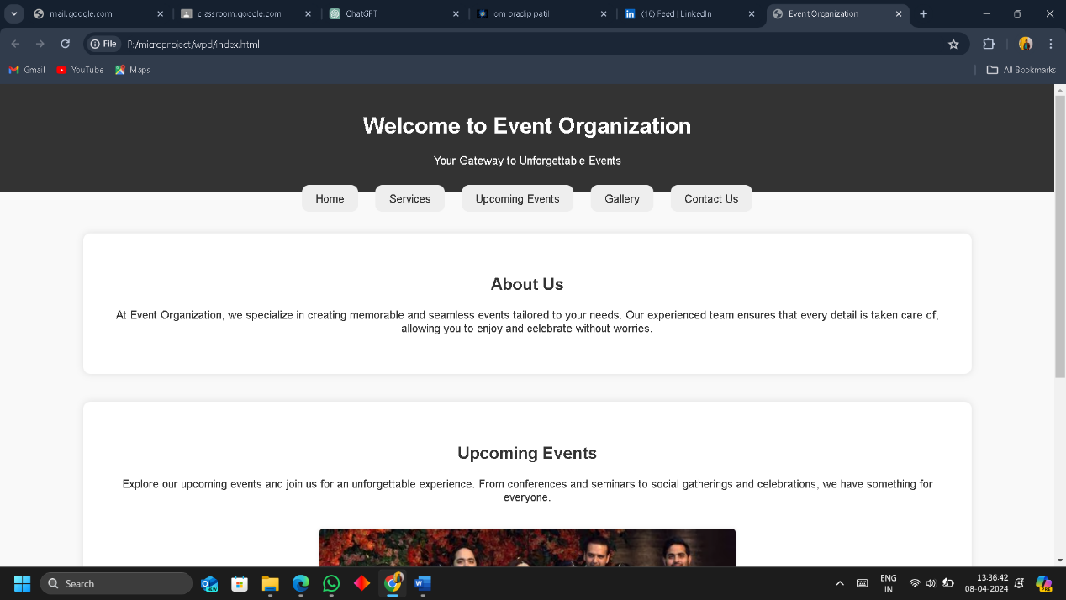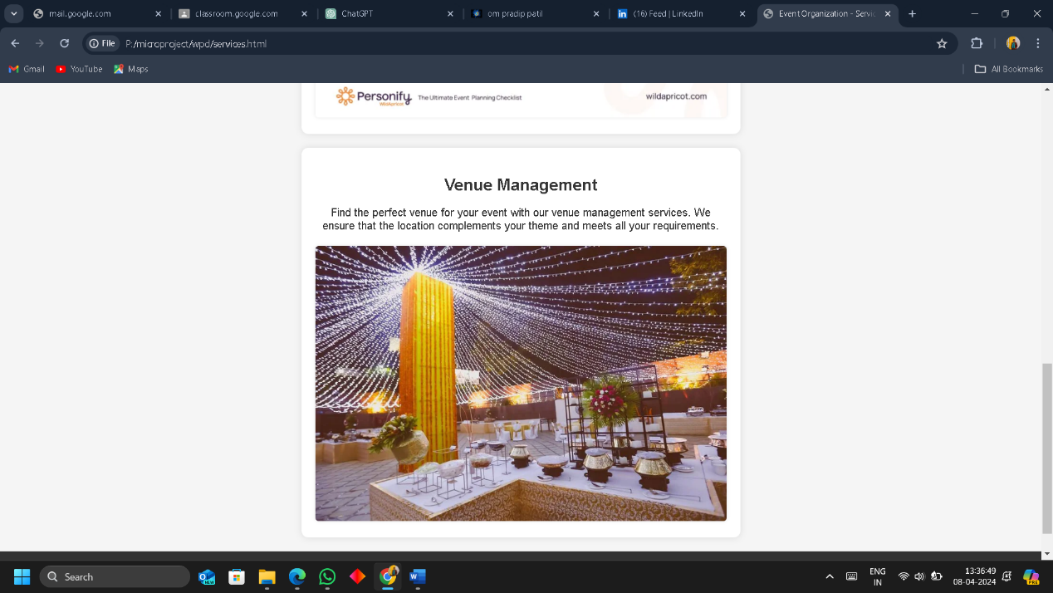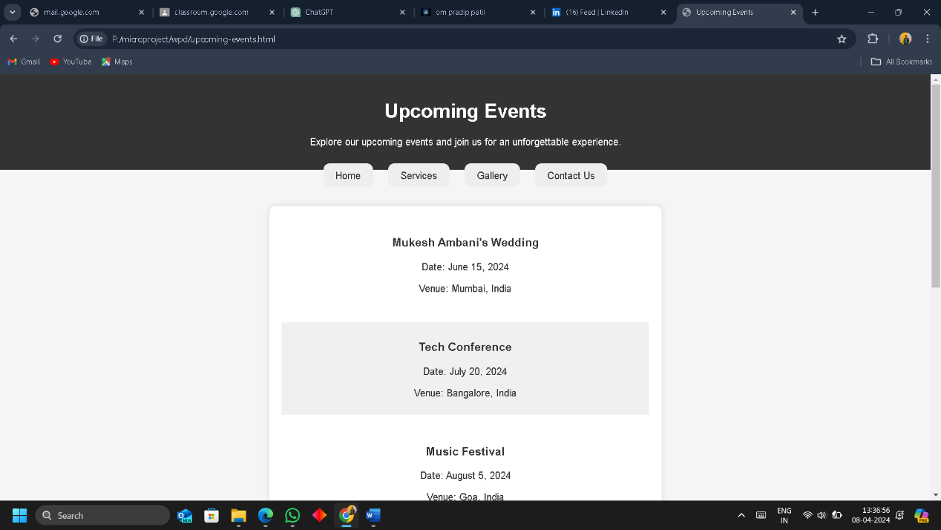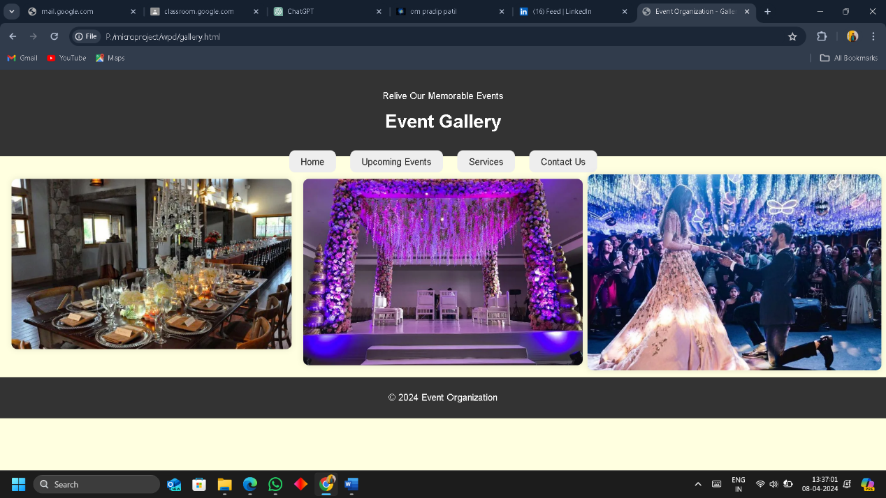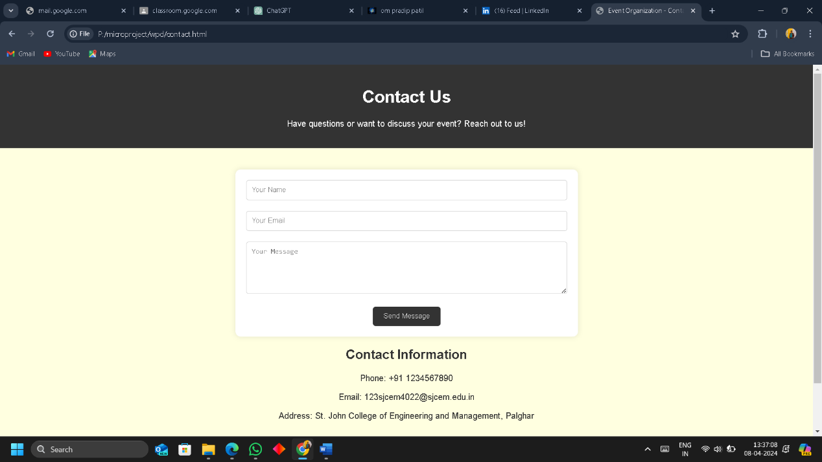

**Conclusion-**

Our microproject journey has been an illuminating exploration into the realms of web development, collaboration, and innovation. As we bring this endeavor to a close, it is imperative to reflect on the myriad lessons learned, accomplishments achieved, and the roadmap ahead.

Reflecting on Achievements

Throughout the duration of this microproject, our team has diligently worked to conceptualize, design, and develop a bespoke HTML website tailored for event organization. This journey has been characterized by a steadfast commitment to excellence, a tireless pursuit of creativity, and a collective vision for crafting an unparalleled digital experience. From the initial brainstorming sessions to the final implementation phase, each step of the process has presented both challenges and opportunities for growth.

Our primary achievement lies in the creation of a user-centric platform that seamlessly integrates functionality, aesthetics, and performance. By prioritizing the needs and preferences of our target audience, we have succeeded in delivering an intuitive interface that fosters engagement, enhances usability, and cultivates a sense of community. Moreover, our emphasis on performance optimization has ensured that the website operates efficiently across various devices and platforms, thereby maximizing accessibility and user satisfaction.

Key Insights and Learnings

The journey of building our microproject has been replete with invaluable insights and learnings that have enriched our understanding of web development principles and practices. Foremost among these insights is the paramount importance of user-centric design and accessibility. By adopting a human-centered approach to design, we have been able to empathize with our users, anticipate their needs, and tailor our solution accordingly. Furthermore, our commitment to accessibility has underscored the significance of inclusivity in digital experiences, prompting us to prioritize features such as responsive design, keyboard navigation, and screen reader compatibility.

Additionally, our journey has underscored the critical role of collaboration, communication, and adaptability in the success of any project. By fostering an environment of open dialogue, constructive feedback, and mutual respect, our team has been able to leverage the diverse skill sets and perspectives of its members to overcome challenges, iterate on ideas, and drive innovation. Moreover, our willingness to embrace change and pivot in response to evolving requirements has enabled us to navigate the complexities of the development process with agility and resilience.

Future Directions

As we conclude this microproject, we are cognizant of the opportunities and challenges that lie ahead on our journey of continuous improvement and innovation. Looking to the future, we are committed to building upon the foundation laid by our current endeavor, leveraging emerging technologies, and incorporating user feedback to enhance the functionality, usability, and scalability of our website.

Central to our future endeavors will be the ongoing pursuit of excellence in all aspects of web development, from design aesthetics to backend functionality. By staying abreast of industry trends, best practices, and technological advancements, we aim to remain at the forefront of innovation and deliver cutting-edge solutions that exceed the expectations of our users.

Furthermore, we recognize the importance of cultivating a culture of lifelong learning and professional development within our team. By investing in the growth and skill development of our members, we not only enhance our collective capabilities but also foster a sense of ownership, pride, and fulfillment in our work.

Acknowledgments

No journey is complete without acknowledging the contributions and support of those who have guided, inspired, and empowered us along the way. We extend our heartfelt gratitude to our mentors for their invaluable guidance, wisdom, and encouragement throughout this microproject. Their expertise, insights, and unwavering support have been instrumental in shaping our journey and propelling us towards success.

Additionally, we express our appreciation to our fellow team members for their dedication, creativity, and camaraderie. Each member has played a vital role in the realization of our collective vision, contributing their unique talents, perspectives, and expertise to the project. Together, we have forged bonds of friendship, collaboration, and shared purpose that will endure long beyond the conclusion of this microproject.

Closing Thoughts

In closing, our microproject journey has been a testament to the transformative power of collaboration, creativity, and perseverance in the pursuit of excellence. As we bid

**References used-**

1. Mozilla Developer Network (MDN): [https://developer.mozilla.org/en-US/docs/Web](https://developer.mozilla.org/en-US/docs/Web)

2. W3Schools: [https://www.w3schools.com/](https://www.w3schools.com/)

3. freeCodeCamp: [https://www.freecodecamp.org/](https://www.freecodecamp.org/)

4. Codecademy: [https://www.codecademy.com/](https://www.codecademy.com/)

5. YouTube Tutorials:

- Traversy Media: [https://www.youtube.com/user/TechGuyWeb](https://www.youtube.com/user/TechGuyWeb)

- The Net Ninja: [https://www.youtube.com/channel/UCW5YeuERMmlnqo4oq8vwUpg](https://www.youtube.com/channel/UCW5YeuERMmlnqo4oq8vwUpg)

- Programming with Mosh: [https://www.youtube.com/user/programmingwithmosh](https://www.youtube.com/user/programmingwithmosh)

-html.5blackbook